

PROJECT REPORT
ON
HEALTH DATA ANALYSIS USING PYTHON

Subject:Python Programming
Subject Code:26CAH-606

Submitted By: Submitted To:
Name:Nistha Singh Dr.Pawandeep Sharma
UID:26MCD10010 (E2916)
Section:26MCD-1A
Group:A

University Institute of Computing
Chandigarh University,Gharuan,Mohali

BONAFIDE CERTIFICATE
This is to certify that Nistha Singh, UID 26MCD10010, student of MCA (Data Science), Section 26MCD-1A, University Institute of Computing, Chandigarh University, has successfully completed the Python Programming mini-project entitled “Health Data Analysis Using Python” under the guidance of the concerned faculty member during the academic session 2026–2027.
This project report is submitted in partial fulfillment of the requirements of the subject Python Programming (26CAH-606).
The work presented in this report is based on the student's efforts and has been completed for academic purposes.

Project Supervisor: Head of Department:
Dr. Pawandeep Sharma Dr. Amanpreet Kaur Sandhu
(E2916) HOD-MCA

ACKNOWLEDGEMENT
I would like to express my sincere gratitude to my faculty guide and the Department of the University Institute of Computing, Chandigarh University, for providing me with the opportunity to work on the mini-project titled “Health Data Analysis Using Python.”
I am thankful to my subject teacher for their valuable guidance, support, and encouragement throughout the development of this project. Their guidance helped me understand the practical applications of Python programming, NumPy, Pandas, and Matplotlib in data analysis and visualization.
I would also like to thank Chandigarh University for providing the necessary learning resources and academic environment to complete this project successfully.
Finally, I am grateful to my family and everyone who supported and encouraged me during the completion of this project.
This project has helped me improve my programming skills and gain practical knowledge of data cleaning, statistical analysis, and graphical representation of health-related data.
Nistha Singh
UID: 26MCD10010
MCA (Data Science)
Section: 26MCD-1A
Chandigarh University

INDEX
S. No. | Contents | Page No.
1 | Project Title / Cover Page | 1
2 | Bonafide Certificate | 2
3 | Acknowledgement | 3
4 | Index | 4
5 | Abstract | 5
6 | Introduction | 6
7 | Problem Statement | 7
8 | Objectives of the Project | 8
9 | Scope of the Project | 9
10 | Hardware and Software Requirements | 10
11 | Technologies Used | 11
12 | Functional Requirements and System Design | 12
13 | Methodology and Source Code | 8–14
14 | Output and Graphical Representation | 15
15 | Advantages, Limitations, Learning Outcomes and Conclusion | 16

ABSTRACT:
Health Data Analysis Using Python is a mini-project developed to demonstrate how programming and data analysis techniques can be used to process and understand health-related information. Health data may include patient age, gender, blood pressure, cholesterol levels, and heart rate. Analysing these values can help organise information and identify patterns within a dataset.
The project uses Python as the main programming language. Pandas is used to store and manage health records in tabular form, while NumPy supports numerical operations, validation, and data filtering. Matplotlib is used to create graphical representations of the analysed data.
The project performs several operations, including displaying patient records, checking missing values, validating selected numerical fields, calculating average health measurements, and filtering records based on a blood pressure threshold. It also generates visualisations such as an age distribution histogram, a gender-wise bar chart, and scatter plots comparing age with blood pressure and cholesterol.
The results are displayed in the terminal and saved in CSV files and an image containing the graphs. These outputs demonstrate how raw data can be organised, analysed, and presented in a meaningful format.
This project is intended for educational purposes and uses sample patient data. It does not provide medical diagnoses or replace professional medical advice.
Keywords: Python, Health Data, NumPy, Pandas, Matplotlib, Data Analysis, Data Visualisation.

Introduction
Health data analysis involves examining health-related information to understand patterns and trends. Healthcare data may include demographic information, vital signs, and laboratory measurements.
Python is a useful programming language for data analysis because it provides libraries such as NumPy, Pandas, and Matplotlib. These libraries help process numerical values, manage datasets, and create visual representations.
This project analyzes sample health records and uses graphs to represent patient demographics and relationships between variables such as age, blood pressure, and cholesterol.

Problem Statement
Health-related datasets may contain large amounts of numerical information, missing values, and patterns that are difficult to identify manually. Without proper analysis, understanding relationships between different health variables can be challenging.
Therefore, this project uses Python to organize and clean a sample health dataset, calculate basic statistics, and visualize the data. The objective is to make the information easier to understand through numerical analysis and graphical representation.

Aim and Objectives
Aim: To develop a Python-based system for analyzing and visualizing health-related data.
Objectives:
- To collect or create a structured health dataset.
- To use NumPy for numerical operations and data filtering.
- To use Pandas for data loading, cleaning, and manipulation.
- To visualize patient demographics using histograms and bar charts.
- To create scatter plots comparing age with blood pressure and cholesterol.
- To calculate descriptive statistics and explore correlations.
- To interpret the results of the analysis.

Scope of the Project
The project focuses on basic health data analysis using Python. It can process sample patient records, calculate statistical summaries, identify missing values, and generate graphical representations.
It is suitable for learning data cleaning, numerical computation, and data visualization. The project can also be extended to larger datasets or an interactive dashboard. However, it is an educational project and is not intended for medical diagnosis or treatment decisions.

Tools and Technologies
Technology | Application
Python | Main programming language
NumPy | Numerical calculations and filtering
Pandas | Data loading and cleaning
Matplotlib | Creating charts and graphs
CSV | Storing structured health data
VS Code / Python IDLE | Writing and running the program

Dataset Description
The project uses a structured CSV file named health_data.csv. Each row represents one sample patient record, and each column stores a specific attribute.
Attribute | Description
Patient ID | Unique identifier for a sample record
Age | Age in years
Gender | Gender category
Blood Pressure | Blood pressure measurement
Cholesterol | Cholesterol measurement
Heart Rate | Heart rate in beats per minute
The dataset should contain synthetic sample records or appropriately de-identified data. Data quality is important because missing or incorrect values can affect the results.

Methodology
The project follows a sequence of steps to analyze the dataset.
1. Data Collection
Prepare the health dataset in CSV format.
2. Data Loading and Cleaning
Load data using Pandas and check missing or invalid values.
3. Data Analysis
Use NumPy and Pandas to filter data and calculate statistics.
4. Data Visualization
Create histograms, bar charts, and scatter plots.
5. Results and Interpretation
Review the actual output and describe the patterns observed.

Source Code:

import numpy as np
import pandas as pd
import matplotlib.pyplot as plt

# Health Data Analysis Using Python

# 1. Create sample health dataset
data = {
"Patient_ID": [101, 102, 103, 104, 105,
106, 107, 108, 109, 110],
"Age": [25, 32, 45, 52, 29, 61, 38, 47, 55, 34],
"Gender": [
"Female", "Male", "Female", "Male", "Female",
"Male", "Male", "Female", "Male", "Female"
],
"Blood_Pressure": [
118, 125, 140, 150, 115, 160, 130, 145, 155, 122
],
"Cholesterol": [
180, 195, 220, 245, 175, 260, 205, 235, 250, 190
],
"Heart_Rate": [72, 76, 80, 85, 70, 90, 78, 82, 88, 74]
}

df = pd.DataFrame(data)

# 2. Save original data
df.to_csv("health_data.csv", index=False)

print("=" * 45)
print(" HEALTH DATA ANALYSIS SYSTEM")
print("=" * 45)

print("\n1. ORIGINAL HEALTH DATA")
print(df.to_string(index=False))

# 3. Dataset information
print("\n2. DATASET INFORMATION")
print("Total patients:", len(df))
print("Total columns:", len(df.columns))
print("\nMissing values:")
print(df.isnull().sum())

# 4. Validate numerical data using NumPy
df["Age"] = np.where(
df["Age"].between(0, 120), df["Age"], np.nan
)

df["Blood_Pressure"] = np.where(
df["Blood_Pressure"].between(1, 299),
df["Blood_Pressure"], np.nan
)

df["Cholesterol"] = np.where(
df["Cholesterol"].between(1, 999),
df["Cholesterol"], np.nan
)

# Remove rows containing missing values
df = df.dropna()

print("\n3. CLEANED DATA")
print(df.to_string(index=False))

# 5. Calculate statistics
print("\n4. HEALTH STATISTICS")
print("Average age:", round(df["Age"].mean(), 2))
print("Average blood pressure:",
round(df["Blood_Pressure"].mean(), 2))
print("Average cholesterol:",
round(df["Cholesterol"].mean(), 2))
print("Average heart rate:",
round(df["Heart_Rate"].mean(), 2))

# 6. Filter records with blood pressure above 140
high_bp = df[df["Blood_Pressure"] > 140]

print("\n5. PATIENTS WITH BLOOD PRESSURE ABOVE 140")
if high_bp.empty:
print("No records found.")
else:
print(high_bp[
["Patient_ID", "Age", "Blood_Pressure", "Cholesterol"]
].to_string(index=False))

# 7. Count patients by gender
print("\n6. PATIENT COUNT BY GENDER")
print(df["Gender"].value_counts())

# 8. Save processed datasets
df.to_csv("cleaned_health_data.csv", index=False)
high_bp.to_csv("high_blood_pressure_patients.csv", index=False)

# 9. Create graphs
plt.figure(figsize=(12, 8))

plt.subplot(2, 2, 1)
plt.hist(df["Age"], bins=5, edgecolor="black")
plt.title("Patient Age Distribution")
plt.xlabel("Age")
plt.ylabel("Number of Patients")

plt.subplot(2, 2, 2)
gender_counts = df["Gender"].value_counts()
plt.bar(gender_counts.index, gender_counts.values)
plt.title("Patient Count by Gender")
plt.xlabel("Gender")
plt.ylabel("Number of Patients")

plt.subplot(2, 2, 3)
plt.scatter(df["Age"], df["Blood_Pressure"])
plt.title("Age vs Blood Pressure")
plt.xlabel("Age")
plt.ylabel("Blood Pressure")

plt.subplot(2, 2, 4)
plt.scatter(df["Age"], df["Cholesterol"])
plt.title("Age vs Cholesterol")
plt.xlabel("Age")
plt.ylabel("Cholesterol")

plt.tight_layout()
plt.savefig("health_analysis_graphs.png", dpi=300)
plt.show()

print("\nFiles saved successfully:")
print("1. health_data.csv")
print("2. cleaned_health_data.csv")
print("3. high_blood_pressure_patients.csv")
print("4. health_analysis_graphs.png")
print("\nProject completed successfully!")
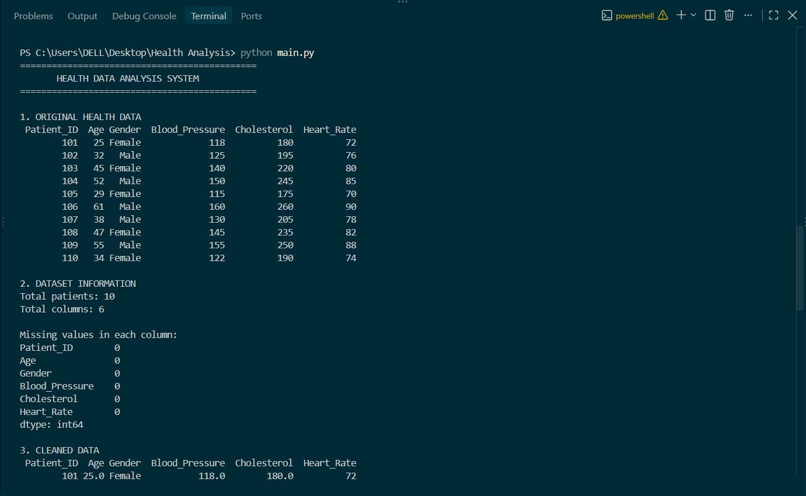
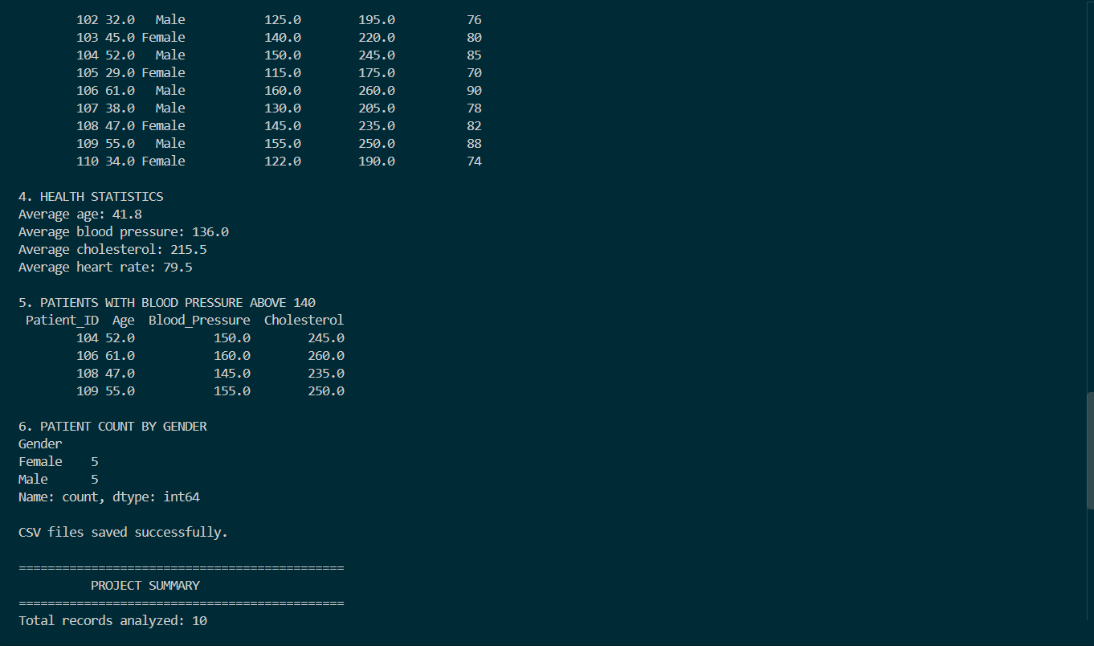
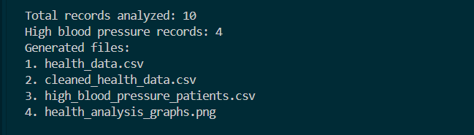

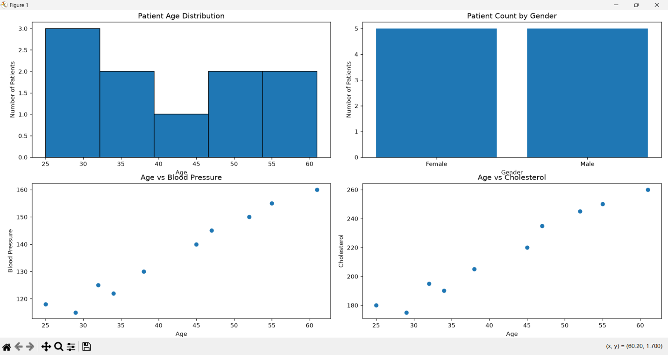

ADVANTAGES, LIMITATIONS, LEARNING OUTCOMES AND CONCLUSION

Advantages
• Automates basic calculations and filtering of health-related records.
• Uses NumPy and Pandas for numerical operations and data handling.
• Presents information through graphs that are easier to understand.
• Saves original, cleaned, and filtered records in CSV files.

Limitations
• The project uses a small synthetic dataset of 10 sample records.
• Results depend on the quality and size of the supplied data.
• The project does not provide medical diagnosis or treatment recommendations.
• The current program is a basic command-line application without a database or interactive dashboard.

Learning Outcomes
• Learned to create and manage a dataset using Pandas.
• Practised numerical validation and filtering using NumPy.
• Calculated averages and checked missing values in a dataset.
• Created histograms, bar charts, and scatter plots using Matplotlib.
• Learned to save processed data and graph output files.

Conclusion
The Health Data Analysis Using Python mini-project demonstrates the basic steps of validating, analysing, and visualising sample health data. NumPy, Pandas, and Matplotlib support calculations, filtering, and graphical presentation. The project fulfils its educational objective and can be extended with larger datasets, additional statistical methods, or an interactive dashboard. The sample results are for learning purposes only and must not be used for medical decisions.

